Smart Conversion of a Conventional Lathe with IIoT Integration using ThingWorx
4EL33 - Industry Defined Project

Submitted by
Meet Chetankumar Soni (21EL035)
In partial fulfillment for the award of the degree
of
Bachelor of Technology
in
Electronics Engineering

Guided By: Prof. (Dr.) Vinay J Patel, Prof. (Dr.) Ashish M Thakkar, Prof. (Dr.) Dipak M Patel

Birla Vishvakarma Mahavidyalaya
Engineering College (An Autonomous Institution)
Vallabh Vidyanagar

2024-2025

Certificate

This is to certify that the project report entitled “Smart Conversion of a Conventional Lathe with IIoT Integration using ThingWorx” submitted by Meet Chetankumar Soni, Roll No. 21EL035, in partial fulfilment of the requirements for the degree of Bachelor of Technology in Electronic Engineering is a record of the candidate’s own work carried out under our supervision and guidance during the academic year 2024–2025.

Industry Guide Industry Guide Faculty Guide
(Dr. Vinay J. Patel) (Dr. Ashish M. Thakkar) (Dr. Dipak M. Patel)

Acknowledgement

I would like to express my sincere gratitude to Dr. Vinay J. Patel, Dr. Ashish M. Thakkar, Dr. Dipak M. Patel, and Prof. Anish Vahora for their invaluable guidance and support throughout this project. Their expertise, insights, and constant encouragement have been instrumental in successfully completing this work. I truly appreciate their time and efforts in helping me overcome challenges and refine my understanding of the subject.

Abstract

Conventional lathe machines lack real-time monitoring and data-driven capabilities, leading to inefficient operations, unexpected downtimes, and limited process insights. To address this gap, the project titled "Smart Conversion of a Conventional Lathe with IIoT Integration Using ThingWorx" was undertaken. The main objective was to modernize a traditional lathe by integrating Industrial Internet of Things (IIoT) technologies, enabling real-time data acquisition, remote monitoring, and predictive analytics.
The methodology involved installing sensors for tracking spindle speed, temperature, vibration, and tool position, developing a PLC-based control system for machine operations, and establishing IIoT connectivity through OPC-UA/Ethernet-IP protocols to the ThingWorx platform. Interactive dashboards were created to visualize operational parameters, machine health, and performance metrics.
The project successfully transformed the conventional lathe into a smart, connected machine, achieving real-time monitoring, improved operational efficiency, predictive maintenance capabilities, and laying the groundwork for Industry 4.0 adoption.

List of Figures

Figure 1.1 Omron NX102 9000 PLC 13
Figure 1.2 Omron NX OD-5256 13
Figure 1.3 Omron NX ID-5442 13
Figure 1.4 Omron NB7W-TW01B HMI Screen 14
Figure 1.5 Pulsate Metal Proximity Sensor 14
Figure 1.6 Selec EM4M Energy Meter 15
Figure 1.7 Vibit Lite Sensor 15
Figure 1.8 USR-TCP232-306 Converter Module 16
Figure 1.9 Sysmac Studio Software 16
Figure 1.10 NB Designer Studio Software 17
Figure 1.11 ThingWorx IIoT Platform 17
Figure 2.1 System Connection Diagram 18
Figure 2.2 System Operation Flowchart 19
Figure 3.1 Sysmac Studio Project Initialization 20
Figure 3.2 Configuring and Programming a PLC 21
Figure 3.3 Configuring PLC-HMI Communication in NB-Designer 22
Figure 3.4 Uploading HMI design via USB/Ethernet and screen layout section in 23
NB-Designer
Figure 3.5 Publishing Variables in Sysmac Studio 24
Figure 3.6 Tags Generated in Kepware Server 25
Figure 3.7 Select the size of Canvas 27
Figure 3.8 Creating the design using widgets 27
Figure 3.9 Binding tags with widgets of design 28
Figure 4.1 Smart lathe setup with integrated PLC control panel 29
Figure 4.2 Vibit lite on Head Stock 30
Figure 4.3 Vibit Lite on Tool Post 30
Figure 4.4 Selec EM4M Energy Meter in PLC Panel 30
Figure 4.5 Chuck Key Detector 31
Figure 4.6 RPM calculation 31
Figure 4.7 HMI Screen Design 31
Figure 4.8 ThingWorx Dashboard 32

Contents

Acknowledgement 2
Abstract 3
List of Figures 4
1 Introduction 9
1.1 Problem summary 9
1.2 Aim & Objective 9
1.2.1 Aim 9
1.2.2 Objectives 9
1.3 Problem Specification 10
1.4 Literature review 11
1.5 Tools & Technologies 13
1.5.1 Programmable Logic Controller (Omron NX102-9000) 13
1.5.2 Digital Input & Output Cards 13
1.5.3 Omron HMI Screen (NB7W–TW01B) 14
1.5.4 Proximity Sensor (Pulsate SX-P118MM1-IPFW2) 14
1.5.5 Energy Meter (Selec EM4M-3P-C-100A) 15
1.5.6 Vibration and Temperature Sensor (Vibit-Lite) 15
1.5.7 Serial to Ethernet Converter (USR-TCP232-306) 16
1.5.8 Sysmac Studio (Version 1.54) 16
1.5.9 NB Designer (Version 1.5) 17
1.5.10 ThingWorx 17

2 Design Methodology & Work Plan 18
2.1 Design Methodology 18
2.2 Work Plan 19

3 System Implementation & Software Walkthrough 20
3.1 Sysmac Studio 20
3.1.1 Step 1: Launch Sysmac Studio 20
3.1.2 Step 2: Navigate to EtherNet/IP Settings 21
3.1.3 Step 3: Configure the IP Address 21
3.1.4 Step 4: Transfer Settings to the Controller 21
3.1.5 Step 5: Perform a Power Cycle (If required) 21
3.1.6 Optional: Verify the IP Address 22
3.2 NB-Designer 22
3.2.1 Step 1: Launch NB-Designer 22
3.2.2 Step 2: Set the HMI Model 22
3.2.3 Step 3: Configure Ethernet Port Settings 22
3.2.4 Step 4: Set Up Communication with PLC 23
3.2.5 Step 5: Download Project to HMI 23
3.2.6 Optional: Test Communication 23
3.3 Kepware Server (Xencenter Application) 24
3.3.1 Step 1: Creating Tags in Sysmac Studio 24
3.3.2 Step 2: Configuring Kepware Server 25
3.3.3 Step 3: Verifying Tag Communication 26
3.4 ThingWorx Dashboard 26
3.4.1 Step 1: Create a New Project 26
3.4.2 Step 2: Create “Things” for Your Devices 26
3.4.3 Step 3: Create the Mashup (Dashboard UI) 27
3.4.4 Step 4: Design the Layout Using Widgets 27
3.4.5 Step 5: Bind Tags to Widgets 28
3.4.6 Step 6: Create Application Key (for Kepware Connection) 28

4 Results & Conclusion 29
4.1 Results 29
4.1.1 Vibit Lite (Vibration and Temperature Sensor) 29
4.1.2 Selec EM4M (Energy Meter) 30
4.1.3 Pulsate Proximity Sensor 30
4.1.4 Omron NB7W-TW01B HMI 31
4.1.5 ThingWorx IIoT Platform 31
4.2 Performance Comparison 32
4.3 Scope of Future Work 33
4.4 Conclusion 33

References 34

Appendices 35

Chapter 1
Introduction

  - Problem Summery
Traditional lathe machines, while reliable, lack real-time monitoring, automation, and data analytics, making them prone to inefficiencies, human error, and unexpected downtime. As Industry 4.0 pushes manufacturing towards digital transformation, conventional lathes struggle to meet modern demands for smart connectivity and data-driven decision-making, highlighting the urgent need for technological upgrades.

  - Aim & Objective
    - Aim
The aim of the project was to enable real-time data acquisition from the lathe machine by integrating smart sensors and control systems. It also focused on allowing remote monitoring and live tracking of machine parameters through an IIoT platform. Another objective was to introduce fault detection and predictive maintenance capabilities to reduce unexpected failures. All of this was done while preserving the core mechanical operations and traditional machining functions of the lathe.
1.2.2 Objectives
- Objectives included the installation and integration of various industrial sensors to measure critical parameters like spindle speed, tool vibration, operational temperature, and feed rate.
- To develop a robust PLC (Programmable Logic Controller) program to automate and control key lathe operations with enhanced safety interlocks.
- To establish seamless communication between the lathe and the ThingWorx IIoT platform using OPC-UA or Ethernet/IP protocols.

  - Problem Specifications
The conventional lathe machine operates solely through manual control, with no integration of real-time monitoring systems, or automation frameworks. The technical and functional limitations identified are as follows:
- Real-Time Monitoring Deficiency: The machine lacks embedded sensors capable of monitoring critical operational parameters. In the upgraded setup, a Vibit Lite vibration-temperature sensor is utilized to track spindle vibrations and thermal conditions, and other sensors for providing early fault detection.
- Absence of Automated Control Systems: Without any programmable controller, the lathe machine operations, including spindle rotation and feed adjustments, were managed manually. The project addresses this by integrating an Omron NX102-9000 PLC, enabling automation, operational safety, and real-time system control.
- Lack of Energy Consumption Monitoring: The conventional setup did not allow energy usage tracking, an important factor for optimizing operational costs. Therefore, a Selec EM4M energy meter was incorporated, communicating operational parameters via the RS485 Modbus protocol for energy analytics.
- Missing Data Acquisition Systems: In the manual configuration, there was no provision for acquiring, logging, or analysing machine health data. The inclusion of Vibit Lite and Selec EM4M over RS485 allows the system to gather high-fidelity operational data, enabling predictive maintenance strategies.
- No IIoT Connectivity: The machine was initially incapable of networked communication. By integrating industrial communication protocols like OPC-UA and Ethernet/IP into the control architecture, along with RS485-based devices, real-time data can now be visualized on the ThingWorx IIoT platform, allowing remote monitoring, fault diagnostics, and performance optimization.
Addressing these specifications is crucial for upgrading the lathe into a smart, Industry 4.0-compliant machine capable of real-time data visualization, predictive diagnostics, and enhanced operational efficiency.

  - Literature Review
1 Digital Intelligence Systems for Lathe
Authors & Year: N. Srikauisgaraman, V. Hari Balaji, L. Gowtham, M. Arikrishnan, P. Aswin (2019)
Technology Used: Digital control, automation, PLC
Findings: The research focuses on integrating digital control and automation into lathe machines, significantly improving lathe accuracy and operational consistency. However, the study mainly emphasizes theoretical aspects and lacks real-world case studies or large-scale industrial application.
- Experimental Model of Industrial Communication Network Based on Modbus RTU
Authors & Year: UJETRM Journal (2021)
Technology Used: Modbus RTU, RS-485, Industrial network design
Findings: This paper demonstrates the design and testing of industrial communication networks using Modbus RTU over RS-485, providing insights into network structure and setup. However, it primarily serves as a training model and does not offer deep insights into large-scale practical deployments.

- Real-Time Monitoring of Lathe Machine Tool Axis Movement
Authors & Year: IJRASET Journal
Technology Used: Encoders, Controllers, Monitoring Systems
Findings: The study highlights how real-time tracking of lathe axis movement using encoders and controllers can significantly improve machining precision. A limitation of this work is the lack of detailed information on how to scale the system for full industrial environments.

- Data Acquisition & Monitoring System Using MODBUS RTU
Authors & Year: H.M.K.K.M.B. Herath, S.V.A.S.H. Ariyathunge, H.D.N.S. Priyankara (2020)
Technology Used: MODBUS RTU, Power measurement devices, Data analysis algorithms
Findings: This research focuses on collecting and analysing industrial sensor data using Modbus RTU and associated power measurement devices. It enables better system monitoring but faces challenges with scalability when applied to larger industrial networks.

- Adding a Digital Readout (DRO) to a Wood Lathe
Authors & Year: Hackaday (2020)
Technology Used: Hall effect sensor, Arduino Nano, Digital Display
Findings: The project discusses creating an affordable digital readout (DRO) system for lathes using simple hardware like Arduino Nano and Hall effect sensors. While cost-effective, it is mostly suitable for DIY hobby applications rather than heavy-duty industrial use.

- Digital Readout (DRO) for Mini Lathe Using Cheap Digital Callipers
Authors & Year: Levy Sound Design (2021)
Technology Used: Digital Callipers, Arduino Nano
Findings: This work demonstrates converting cheap digital callipers into a functional DRO system for mini lathes. Although innovative, the accuracy heavily depends on the quality of the callipers and may not be suitable for high-precision industrial machining.

- Smart Maintenance in Lathe Machine Shop Through IoT
Authors & Year: Venkatesh Begori, Anil Kumar Reddy Chinnagi Reddy, Pavan Kumar Penta, Vamshi Ramavath, Harinath Lodinga (2023)
Technology Used: Arduino-based IoT interface, Blynk app, real-time monitoring
Findings: This study presents an IoT-based smart maintenance system for lathe machines, integrating Arduino microcontrollers with sensors to monitor machine parameters in real time. The system utilizes the Blynk application to provide a user-friendly interface for remote monitoring, enabling operators to track machine status and receive alerts for maintenance needs. The implementation of this system demonstrated improved machine uptime and reduced unexpected breakdowns, highlighting the effectiveness of IoT solutions in enhancing maintenance strategies for traditional lathe machines.

1.5 Tools & Technologies
1.5.1 Programmable Logic Controller (Omron NX102-9000)
The Omron NX102-9000 is an advanced machine automation controller designed for high-speed, high-precision industrial applications. It combines real-time control with seamless integration of factory automation and IT systems, making it ideal for smart manufacturing environments. Featuring built-in Ethernet/IP and Ether CAT communication, it supports fast data exchange, synchronized motion control, and easy connectivity with IIoT platforms. The NX102-9000 is also scalable, allowing integration of various I/O modules and safety devices, making it a powerful solution for complex automation tasks.
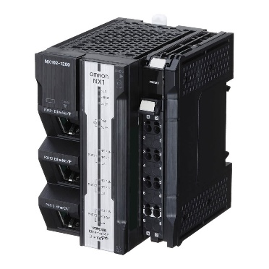
Figure 1.1 Omron NX102 9000 PLC

1.5.2 Digital Input & Output Cards
The Omron NX-ID5442 is a digital input module designed for high-speed, high-precision signal acquisition, capable of receiving up to 16 digital inputs with fast response times for real-time machine control. The NX-OD5256 is a digital output module that provides 16 high-speed output channels.
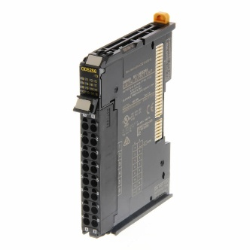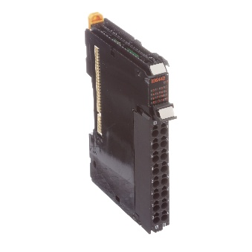
Figure 1.2 Omron NX OD-5256 Figure 1.3 Omron NX ID-5442
1.5.3 Omron HMI Screen (NB7W–TW01B)
The Omron NB7W-TW01B is a 7-inch Human Machine Interface (HMI) designed for easy and intuitive interaction with industrial automation systems. It features a widescreen TFT LCD display with a resolution of 800x480 pixels, offering clear visualization of machine data, alarms, and control settings. The NB7W series supports multiple communication protocols, including RS232, RS422/485, and Ethernet, making it highly versatile for connecting with PLCs and other devices. Its user-friendly programming environment (NB-Designer) allows for the creation of customized screens.
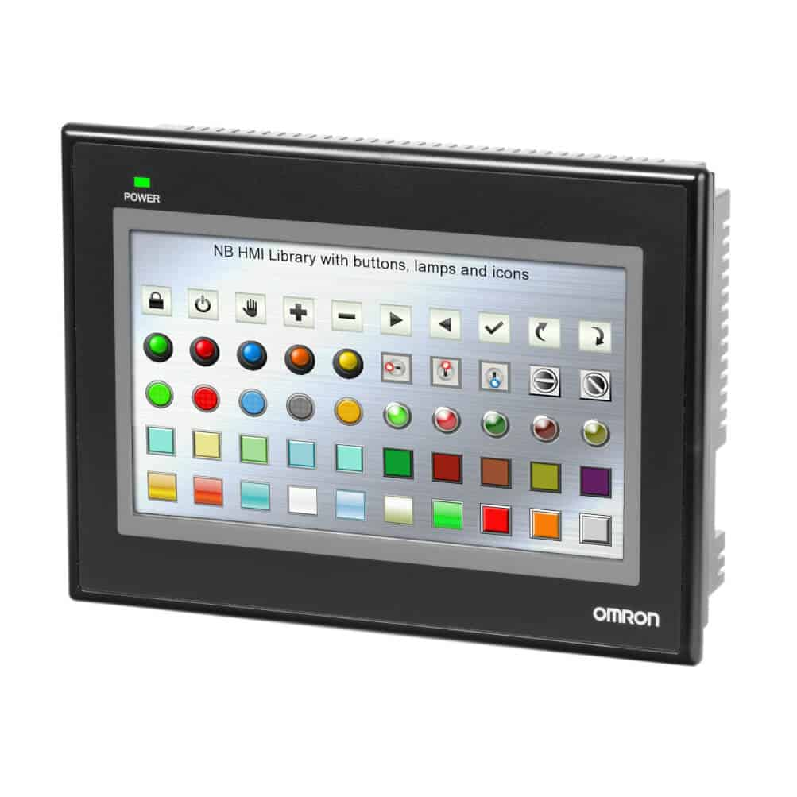
Figure 1.4 Omron NB7W-TW01B HMI Screen

1.5.4 Proximity Sensor (Pulsate SX-P118MM1-IPFW2)
The Pulsate SX-P118MM1-IPFW2 is a compact inductive proximity sensor with a 5mm sensing range, operating on a 10-30V DC supply and supporting a 200mA load current. It is designed for reliable metal detection even in tough environments, with an operating temperature range of -20°C to 70°C. Its fast and stable performance makes it ideal for industrial automation and machine safety applications.
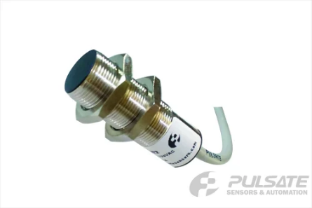
Figure 1.5 Pulsate Metal Proximity Sensor

1.5.5 Energy Meter (Selec EM4M-3P-C-100A)
The Selec EM4M is a compact and reliable energy meter designed for monitoring key electrical parameters like voltage, current, power, and energy consumption in industrial systems. It supports RS485 Modbus communication, allowing easy integration with PLCs and IIoT platforms for real-time energy tracking. With its high accuracy and robust design, the EM4M helps improve energy management and machine efficiency in smart manufacturing setups.
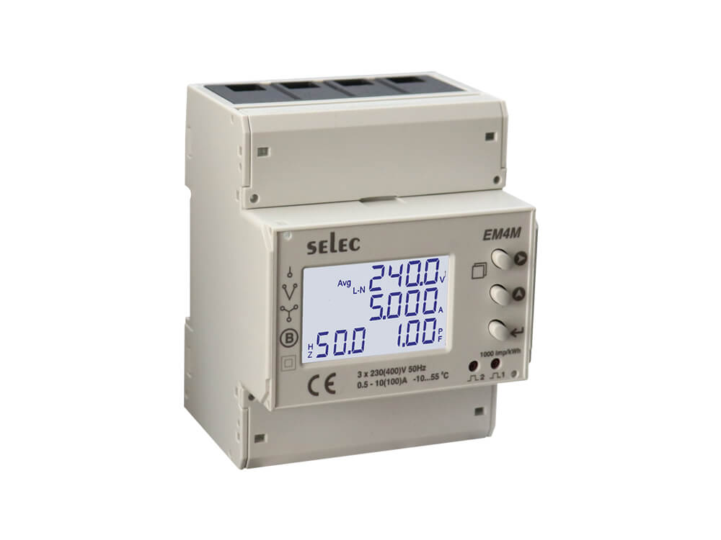
Figure 1.6 Selec EM4M Energy Meter

1.5.6 Vibration and Temperature Sensor (Vibit-Lite)
The Vibit Lite is a compact industrial sensor designed to measure both vibration and temperature in rotating machinery. It communicates via RS485 Modbus protocol, making it easy to integrate with PLCs and IIoT systems for real-time monitoring. With its high sensitivity and rugged build, Vibit Lite helps in early fault detection, predictive maintenance, and improving the overall reliability of machines.
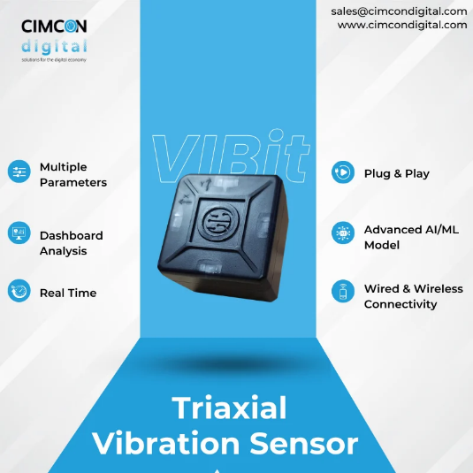
Figure 1.7 Vibit Lite Sensor

1.5.7 Serial to Ethernet Converter (USR-TCP232-306)
The USR-TCP232-306 is a Serial-to-Ethernet converter designed for industrial and IoT applications. It supports RS232, RS485, and RS422 interfaces, enabling communication between serial devices and Ethernet networks. Its features include TCP/UDP protocols, Modbus RTU to TCP conversion, and remote monitoring capabilities, making it ideal for automation.
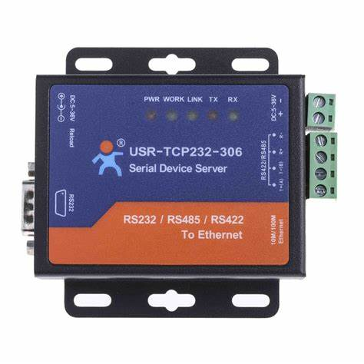
Figure 1.8 USR-TCP232-306 Converter Module

1.5.8 Sysmac Studio (Version 1.54)
Sysmac Studio is Omron’s all-in-one automation software designed for programming, configuring, and monitoring industrial control systems. It provides a single platform to work with PLCs, motion controllers, vision systems, safety devices, and HMIs, allowing seamless project development and integration. Sysmac Studio offers advanced features like real-time debugging, and network configuration tools, reliable automation systems efficiently.
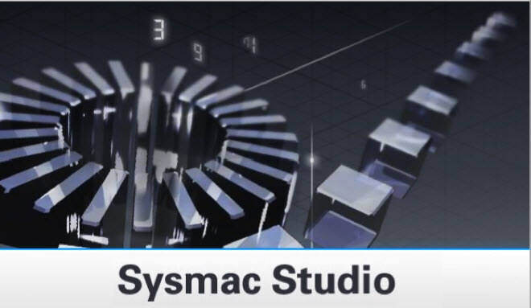
Figure 1.9 Sysmac Studio Software

1.5.9 NB Designer (Version 1.5)
NB-Designer is Omron’s software tool used for creating and configuring HMI screens for the NB series of HMIs. It offers an easy-to-use drag-and-drop interface to design buttons, alarms, data displays, and other control elements. NB-Designer makes it simple to build interactive, customized operator interfaces and supports quick communication setup with PLCs, helping improve monitoring and control in automation projects.

Figure 1.10 NB Designer Studio Software

1.5.10 ThingWorx
ThingWorx is a powerful Industrial Internet of Things (IIoT) platform developed by PTC that enables real-time connectivity, data visualization, and analytics for smart manufacturing systems. It allows devices, sensors, and machines to be connected over secure networks, providing live monitoring, performance tracking, and predictive maintenance insights. With its easy-to-use dashboard tools, drag-and-drop widgets, and strong integration capabilities, ThingWorx helps industries transform traditional machines into smart, data-driven assets.

Figure 1.11 ThingWorx IIoT Platform

Chapter 2
Design Methodology & Work Plan

2.1 Design Methodology
Initially, parameters such as spindle speed, vibration, temperature, and energy consumption were identified as key factors to monitor. Based on this, the Vibit Lite vibration-temperature sensor, Selec EM4M energy meter, and Pulsate proximity sensor were selected. The Omron NX102-9000 PLC was chosen for its high-speed processing and built-in Ethernet/IP and OPC-UA support, with an RS485 to Ethernet converter used to connect the RS485-based sensors.
For programming and interface design, Sysmac Studio was used for PLC logic development, and NB-Designer was used to create HMI screens for the Omron NB7W-TW01B. Xencenter acted as the communication bridge between the PLC and the ThingWorx IIoT platform, where real-time dashboards were developed for remote monitoring and analytics. The implementation followed a modular approach, with each subsystem integrated and tested step-by-step before final validation.
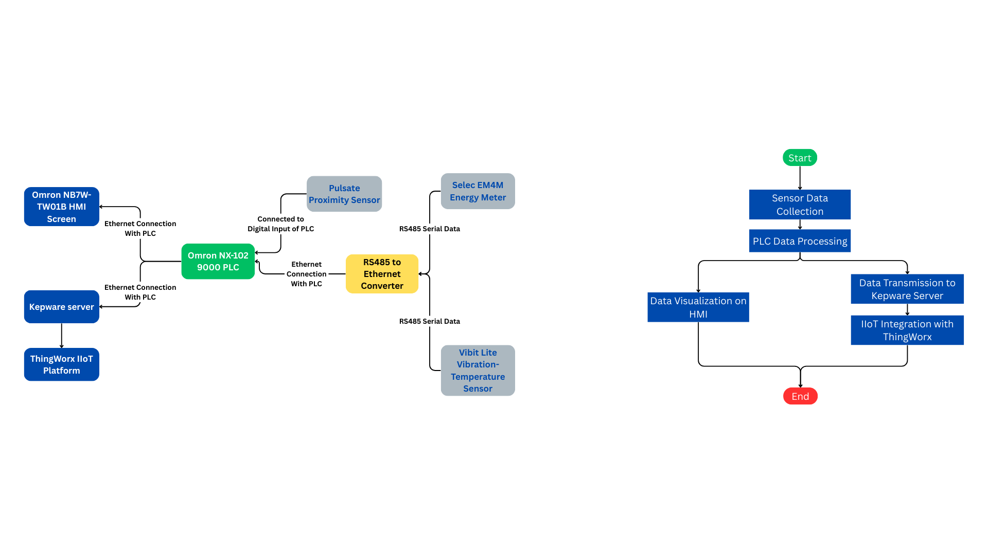
Figure 2.1 System Connection Diagram

Figure 2.1 shows the planned hardware and communication layout involving sensors, PLC, HMI, RS485 to Ethernet conversion, and ThingWorx IIoT integration.
2.2 Work Plan
During the implementation phase, multiple tasks were systematically completed to ensure smooth integration of the components with the conventional lathe machine. Sensors such as the Vibit Lite and Selec EM4M were wired and configured to communicate via RS485 protocol to an RS485 to Ethernet converter, which connected to the PLC over Ethernet, while the Pulsate proximity sensor was directly wired into the digital input card (NX-ID5442) of the PLC.
A detailed PLC program was developed using Sysmac Studio to collect sensor data, control machine logic, trigger alarms for abnormal conditions, and update real-time data to both the HMI and Kepware Server. An interactive HMI interface was designed using NB-Designer, allowing operators to view critical parameters like spindle speed, temperature, vibration levels, energy consumption, and system alerts.
Data from the PLC was transmitted to the Kepware Server, enabling integration with the ThingWorx IIoT Platform where custom dashboards were created for real-time monitoring and analytics. Extensive independent and system-wide testing was carried out to validate reliable communication, control, and visualization across all components.

Figure 2.2 System Operation Flowchart
Figure 2.2 illustrates the data flow in the smart lathe system. Sensor data is collected and processed by the PLC. The PLC then simultaneously updates the HMI for local monitoring and transmits data to the ThingWorx IIoT platform via the Kepware server for remote analytics and visualization.
Chapter 3
System Implementation & Software Walkthrough
This chapter provides a detailed walkthrough of the software tools used in the smart lathe conversion project. It explains the implementation process using Sysmac Studio for PLC programming, NB-Designer for HMI design, Kepware Server for communication bridging, and ThingWorx for IIoT dashboard development. Each software platform played a key role in achieving real-time monitoring, control, and data visualization.

3.1 Sysmac Studio
3.1.1 Step 1: Launch Sysmac Studio
- Start Sysmac Studio.
- Open an existing project or create a new one.
- Ensure the controller is correctly selected in the project settings.
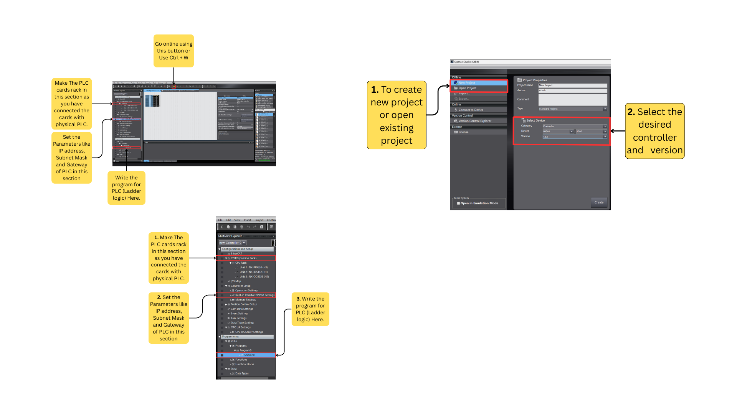
Figure 3.1 Sysmac Studio Project Initialization

Figure 3.2 Configuring and Programming a PLC

3.1.2 Step 2: Navigate to EtherNet/IP Settings
- In the Multiview Explorer, go to: Configurations and Setup → Controller Setup → Built-in EtherNet/IP Port Settings.
3.1.3 Step 3: Configure the IP Address
- Click on Built-in EtherNet/IP Port Settings.
- Under IP Address Settings, you will find: IP Address, Subnet Mask, Default Gateway (optional)
- Set the values as needed.
3.1.4 Step 4: Transfer Settings to the Controller
- Connect your PC to the PLC via USB or Ethernet.
- Go Online (Ctrl + W) → Transfer to Controller (Ctrl + T).
- Make sure to select Transfer Settings and include Ethernet Settings.
- Click Transfer and wait for the operation to complete.

3.1.5 Step 5: Perform a Power Cycle (If required)
- In some cases, restart (power cycle) the PLC to apply the new IP address settings.
3.1.6 Optional: Verify the IP Address
- Open Command Prompt on your PC.
- Type: “ping (IP Address you have set for the PLC)”
- Alternatively, use CX-Ping Tool or Sysmac Studio’s Direct Connection by IP feature to verify the connection.

3.2 NB-Designer
3.2.1 Step 1: Launch NB-Designer
- Open the NB-Designer software on your PC.
- Create a new project or open your existing HMI project.
3.2.2 Step 2: Set the HMI Model
- Go to Project → System Settings.
- Under Model, select the correct HMI model (NB7W-TW01B).
3.2.3 Step 3: Configure Ethernet Port Settings
- Select Ethernet Port from the left panel.
- Set the required IP Address, Subnet Mask, and Default Gateway.
- Ensure the IP address is within the same network range as the PLC.
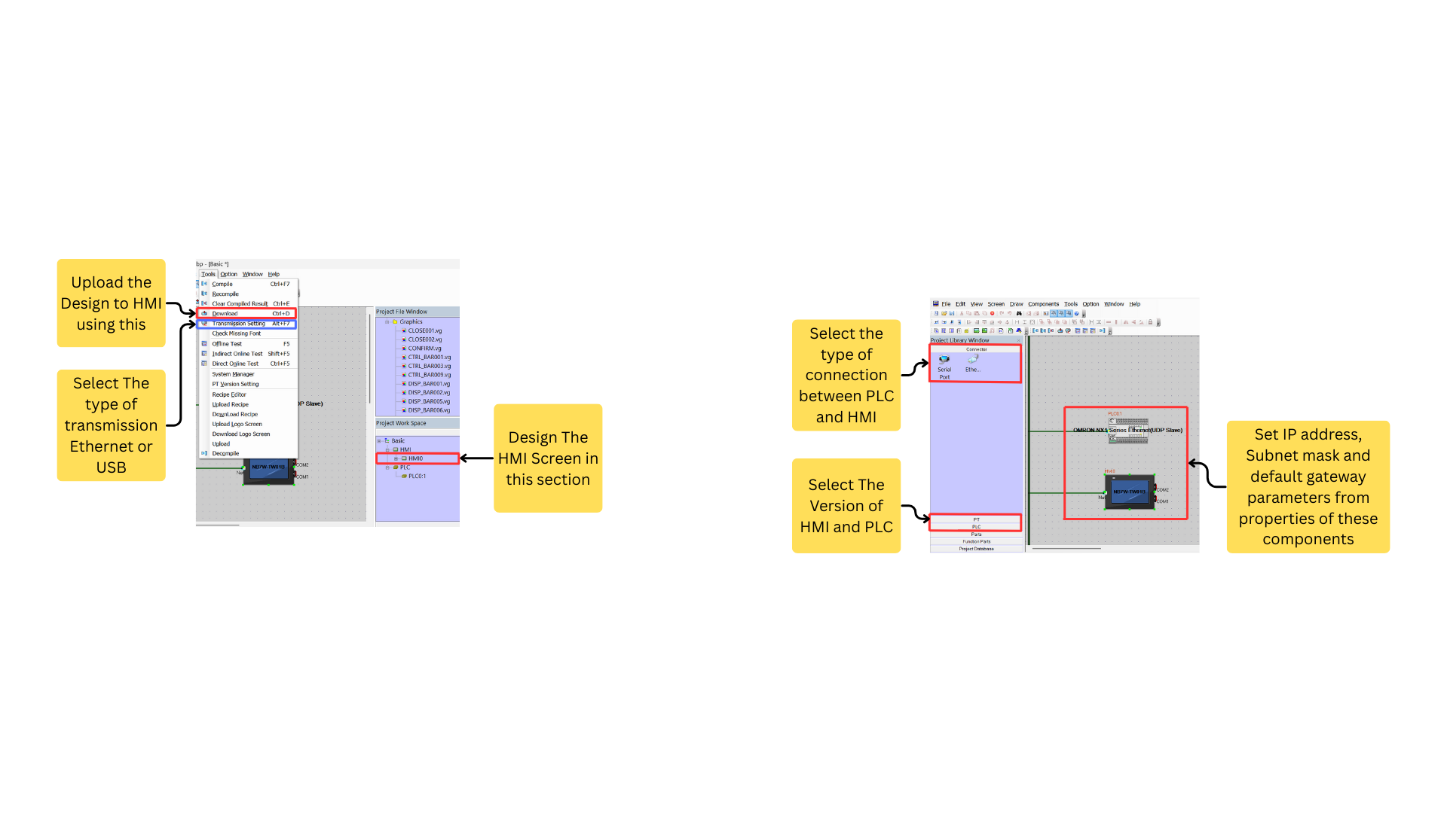
Figure 3.3 Configuring PLC-HMI Communication in NB-Designer

3.2.4 Step 4: Set Up Communication with PLC
- In System Settings, open the Device Settings tab.
- Add a new device with the following configuration:
  - PLC Type: OMRON NX Series Ethernet (UDP Slave)
  - Connection Method: Ethernet
  - PLC IP Address: Enter the IP of the connected NX102-9000 PLC.
  - Port Number: Use the default setting.
3.2.5 Step 5: Download Project to HMI
- Connect your PC to the HMI via USB or Ethernet.
- Go to Communication → Download to HMI.
- Choose the appropriate connection method USB for First time setting the IP address of HMI screen and downloading the visual to HMI screen or Ethernet for second time updating the visual of HMI screen.
- Click Download and wait for the process to complete.

Figure 3.4 Uploading HMI design via USB/Ethernet and screen layout section in NB-Designer

3.2.6 Optional: Test Communication
- Power on both the HMI and PLC.
- Check if the HMI correctly displays live data from the PLC without any communication errors.

3.3 Kepware Server (Xencenter Application)
3.3.1 Step 1: Creating Tags in Sysmac Studio
- Open Sysmac Studio and load your NX102-9000 PLC project.
- Ensure the PLC is connected and online. Note the PLC’s IP address for later use in Kepware.
- Go to the Global Variables section of your program.
- Define the variables (tags) you want to expose to ThingWorx through Kepware.
- Make sure the variable scope is set to Publish Only.
- Save the program, build it, and transfer the project to the PLC.
- Go online and upload your program to activate the tag values.
- Confirm the PLC is actively connected and online while you proceed with Kepware setup.
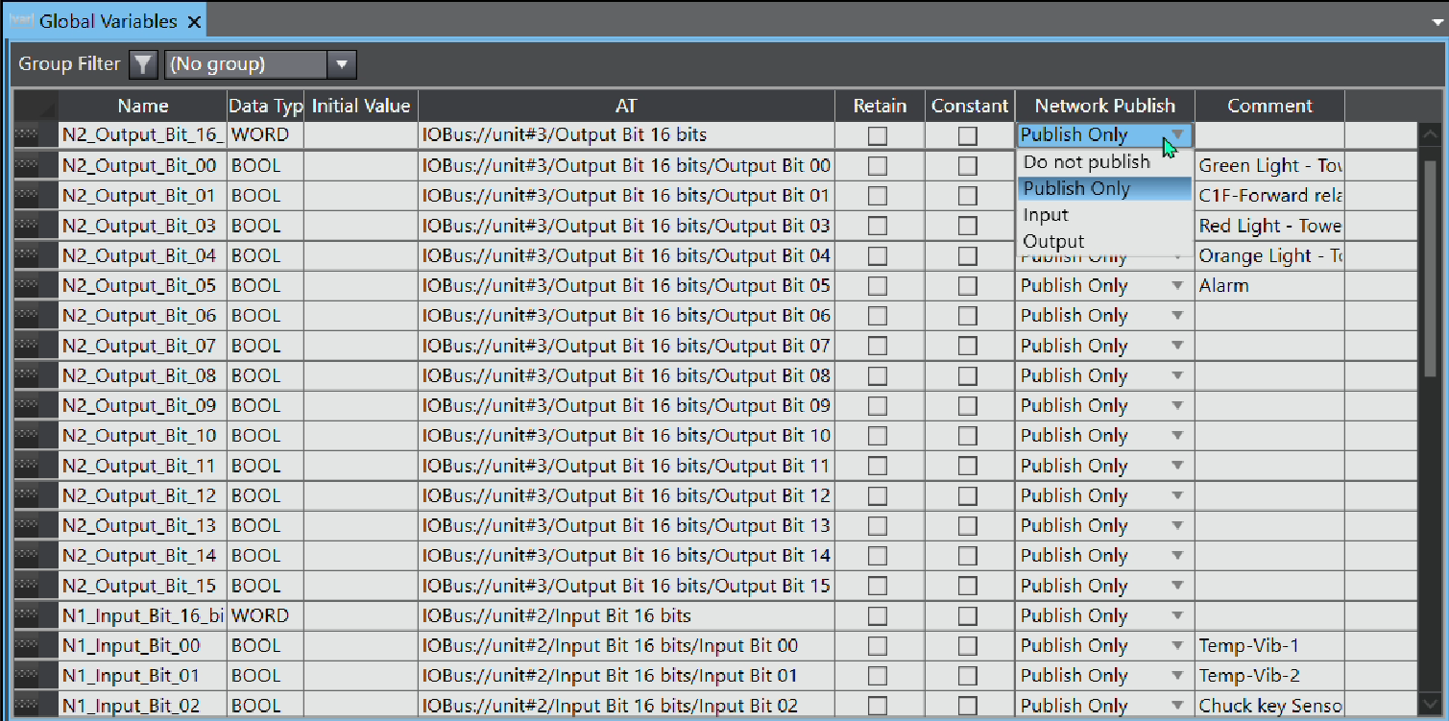
Figure 3.5 Publishing Variables in Sysmac Studio

3.3.2 Step 2: Configuring Kepware Server
- Open ThingWorx Kepware Server Configuration tool on your PC.
- Go to File → New to create a new project.
Channel Setup:
- Click on "Click to add a channel" under Connectivity.
- Select "OPC UA Client" from the drop-down and click Next.
- Enter a channel name (e.g., “Omron_PLC”) and click Next.
- When prompted for the server endpoint, enter the PLC’s OPC UA endpoint, like: opc.tcp://<PLC_IP_ADDRESS>:4840
- Set Security Policy to None if your PLC allows unencrypted access (for testing).
- Click Next multiple times until you reach Finish.
Device Setup:
- Click "Click to add a device" under the channel you just created and give the device a name (e.g., “NX102_Device”).
- Proceed through the steps until you see the “Select Import Item” window.
- Navigate to your PLC tags path (usually available under Global Variables in Sysmac Studio).
- Select the required tags and click "Add Items", then confirm by clicking OK.
- Complete the remaining steps by clicking Next → Finish.
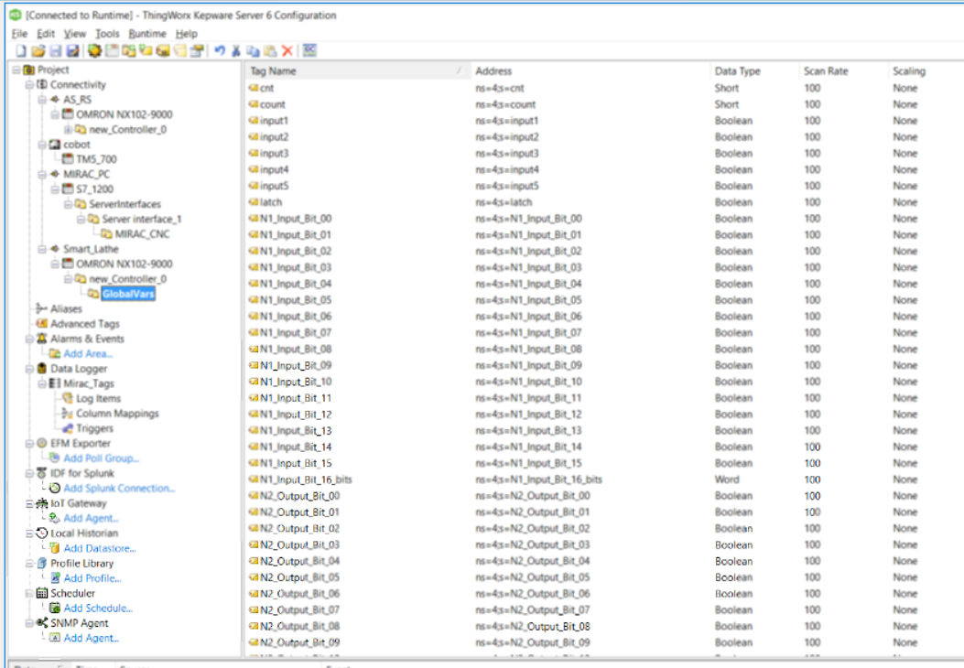
Figure 3.6 Tags Generated in Kepware Server
3.3.3 Step 3: Verifying Tag Communication
- Expand the Device tree in Kepware to locate your device and added tags.
- Click on the Quick Client tool in Kepware to monitor live tag values.
- If everything is set up correctly, you should now see real-time values updating from your PLC.

3.4 ThingWorx Dashboard
    - Step 1: Create a New Project
- Open Browser write ‘10.10.8.61:8080/ThingWorx’ in URL and enter Username: ‘Administrator’ Password: ‘smart@bvm_lab_thingworx’ to login in ThingWorx.
- Go to the Browse tab → click + New → select Project.
- Name the project (e.g., Smart_Lathe_Dashboard).
- Set visibility and save the project.

3.4.2 Step 2: Create “Things” for Your Devices
- Go to Browse → + New → Thing.
- Create a new Thing (e.g., Lathe_Thing) to represent the smart lathe system.
- Assign a Thing Template (e.g., GenericThing).
- Under Properties, add custom tags like:
  - SpindleSpeed (Base type: Number)
  - Temperature (Base type: Number)
  - VibrationLevel (Base type: Number)
  - EnergyConsumption (Base type: Number)
  - SafetyProximity (Base type: Boolean)
3.4.3 Step 3: Create the Mashup (Dashboard UI)
- Go to Browse → + New → Mashup.
- Choose a Static (Legacy) template for easier widget positioning.
- Set Canvas Size to 1280x720 (HD) or as needed.
- Name the mashup (e.g., Lathe_Monitor_UI) and assign it to your project.
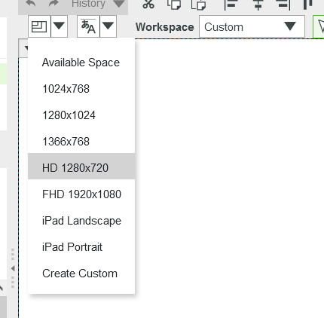
Figure 3.7 Select the size of Canvas

3.4.4 Step 4: Design the Layout Using Widgets
- Use Shapes or Gauges to visualize sensor values like speed, vibration, temp, etc.
- Use Labels to display text or tag names.
- Customize colours, borders, and fonts in Style Properties.
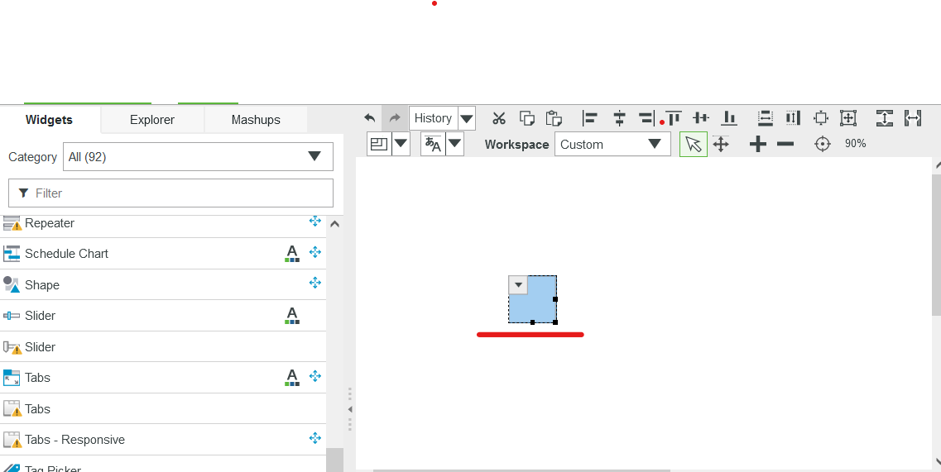
Figure 3.8 Creating the design using widgets

3.4.5 Step 5: Bind Tags to Widgets
- In the Data panel, click the + icon and choose the Thing you created earlier (e.g., Lathe_Thing).
- Select Services → GetPropertyValues.
- Drag the desired property (e.g., Temperature, SpindleSpeed) and drop it on the appropriate widget to bind it.
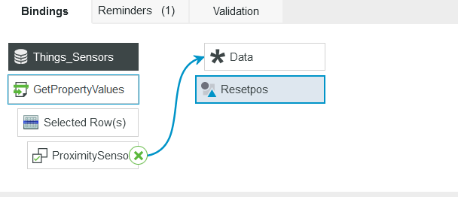
Figure 3.9 Binding tags with widgets of design

3.4.6 Step 6: Create Application Key (for Kepware Connection)
- Go to Browse → + New → Application Key under Security.
- Set project to your current one and assign user as Administrator.
- Save the key and copy the Key ID. This will be used in Kepware for authenticated communication.

Chapter 4
Results & Conclusion

4.1 Results
The smart lathe system was successfully implemented with real-time monitoring, improved safety, and IIoT connectivity. Each sensor played a specific role in enhancing machine visibility and automation. The connection of all components was done in a structured way, enabling reliable data acquisition and visualization.
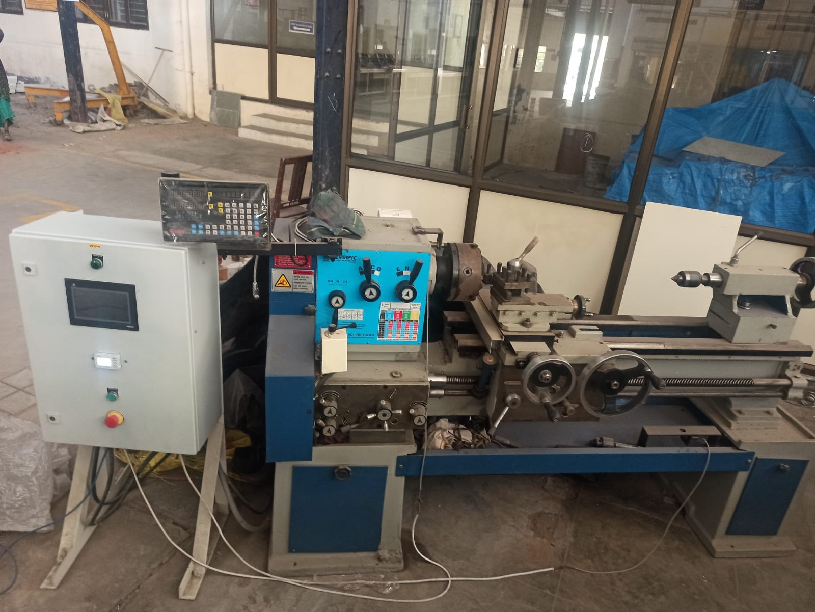
Figure 4.1 Smart lathe setup with integrated PLC control panel

4.1.1 Vibit Lite (Vibration and Temperature Sensor)
The Vibit Lite sensor is used to measure both vibration and temperature at critical points of the lathe, such as the spindle or motor. It is connected to the PLC via an RS485 interface and sends real-time data which is further transmitted to the ThingWorx platform through Kepware. This sensor helps in detecting abnormal conditions like excessive vibration or overheating, which supports predictive maintenance strategies. The collected data is also displayed on the HMI for local monitoring.
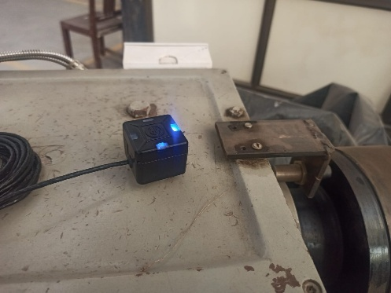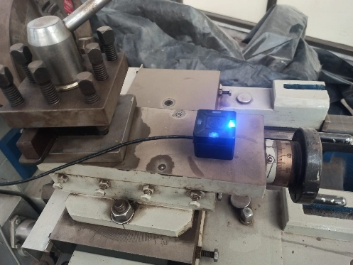
Figure 4.2 Vibit lite on Head Stock Figure 4.3 Vibit Lite on Tool Post

4.1.2 Selec EM4M (Energy Meter)
The Selec EM4M energy meter is used to monitor the electrical parameters of the lathe machine, such as voltage, current, and power consumption. It is connected to the system via RS485 and communicates through a converter to the PLC. The energy data helps track load behaviour and overall energy efficiency. This information is displayed on both the local HMI and the ThingWorx dashboard for real-time monitoring and historical analysis.
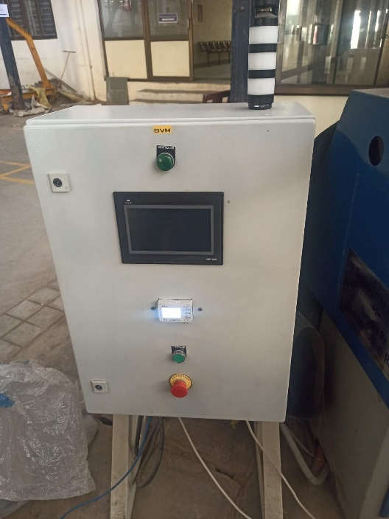
Figure 4.4 Selec EM4M Energy Meter in PLC Panel

4.1.3 Pulsate Proximity Sensor
The Pulsate proximity sensor is a digital sensor connected directly to the PLC's digital input card. It is used to detect the presence of chuck key, within a predefined safety or functional zone and also used this sensor to calculate the RPM of the spindle. The sensor provides binary feedback (ON/OFF), which is essential for implementing safety interlocks and automation logic. The status of the proximity sensor is also shown on the HMI, helping operators react quickly to any unexpected machine behaviour.
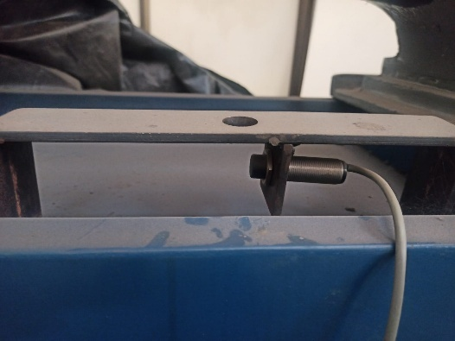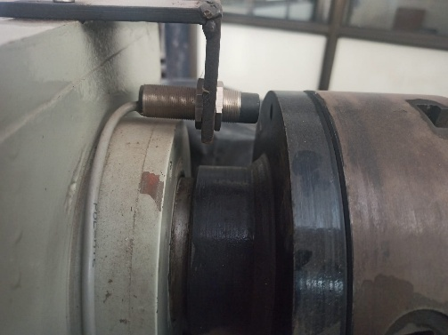
Figure 4.5 Chuck Key Detector Figure 4.6 RPM calculation

4.1.4 Omron NB7W-TW01B HMI
The Omron NB7W-TW01B HMI serves as the user interface for the system, displaying real-time data from all connected sensors. It communicates with the PLC over Ethernet and allows operators to view current system conditions, sensor readings, and alarm notifications. The HMI design includes visual indicators for vibration, temperature, energy usage, and safety triggers, enhancing local monitoring and operator control.
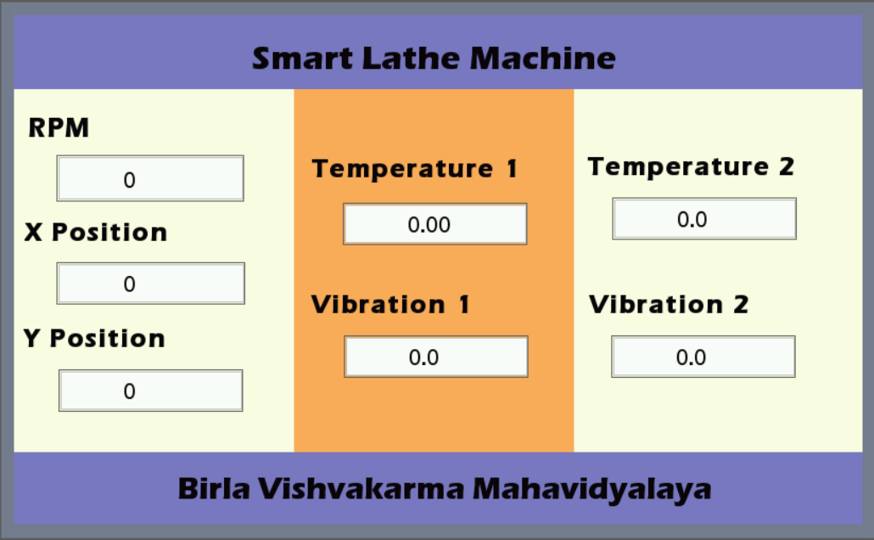
Figure 4.7 HMI Screen Design

4.1.5 ThingWorx IIoT Platform
ThingWorx is the IIoT platform used to visualize and monitor live machine data remotely. It receives real-time values from the PLC via the Kepware Server and displays them on a custom-built dashboard. The platform provides interactive widgets for each key parameter, such as vibration levels, spindle speed, and energy consumption. ThingWorx also lays the foundation for future integration of analytics, alarms, and machine learning models to enhance predictive maintenance and operational efficiency.
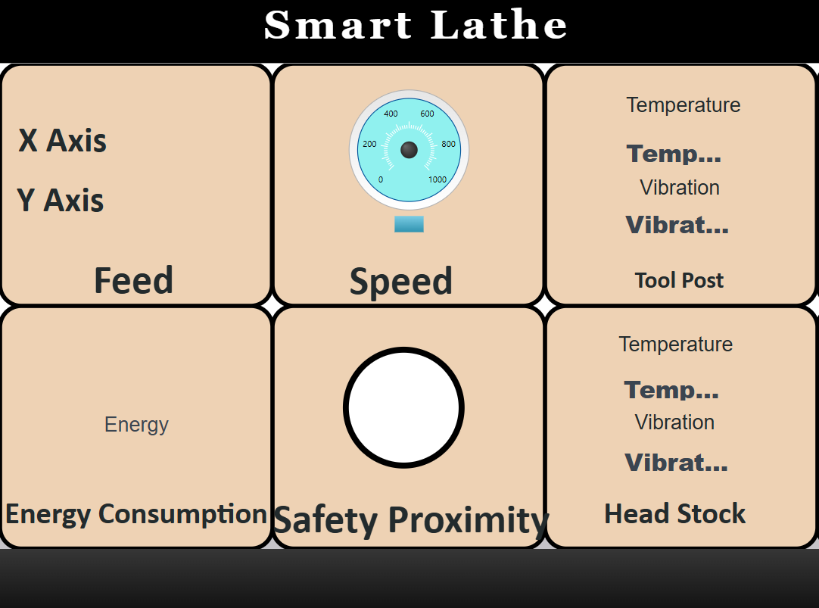
Figure 4.8 ThingWorx Dashboard
4.2 Performance Comparison
Compared to traditional lathe machines and basic retrofitted systems, the smart lathe developed in this project offers significant advantages in terms of connectivity, automation, and data visibility. Conventional lathes lack real-time monitoring and are highly dependent on manual operation, leading to inefficiencies and unexpected failures. In contrast, this system integrates sensors, PLC control, HMI interaction, and IIoT connectivity to offer a modernized solution aligned with Industry 4.0 standards. Unique features such as RS485-based sensor integration, remote data visualization through ThingWorx, and alarm-based feedback systems make this project more advanced than typical retrofitting methods. Additionally, the use of open communication protocols like OPC-UA and structured modular design makes the system highly scalable and ready for future industrial expansions.

4.3 Scope of Future Work
While the system meets its primary objectives, there is considerable scope for improvement and extension. One potential enhancement is the addition of machine learning algorithms within the ThingWorx platform to predict failures based on historical sensor data. The integration of a digital readout (DRO) system can further improve precision monitoring of tool positions. Expanding the setup to include multiple machines connected under a single network would allow for a full smart shop-floor environment. Additionally, developing a mobile-based monitoring application can make the system more accessible and operator-friendly. Enhancing the HMI with advanced graphical displays and multi-language support would further improve usability in industrial settings.

4.4 Conclusion
This project successfully demonstrates the transformation of a conventional lathe into a smart, connected machine using industrial-grade hardware and IIoT technologies. By integrating sensors for vibration, temperature, energy, and proximity detection with a PLC-controlled system, and by enabling remote visualization through platforms like Kepware and ThingWorx, the project addresses the core limitations of traditional machinery. The system improves operational efficiency, provides predictive maintenance capabilities, and reduces the dependency on manual intervention. Overall, the smart lathe conversion aligns with modern manufacturing demands and serves as a scalable foundation for future industrial automation upgrades.

References

[1] H. M. K. K. M. B. Herath, S. V. A. S. H. Ariyathunge, and H. D. N. S. Priyankara, “Development of a Data Acquisition and Monitoring System Based on MODBUS RTU Communication Protocol,” International Journal of Innovative Science and Research Technology (IJISRT), vol. 5, no. 1, pp. 20–23, Jan. 2020.
[2] L. Sound Design, “Digital Readout (DRO) for Mini Lathe Using Cheap Digital Calipers,” Levy Sound Design Blog, Jan. 2021.
[3] N. Srikausigaraman, V. Hari Balaji, L. Gowtham, M. Arikrishnan, and P. Aswin, “Digital Intelligence Systems for Lathe,” International Journal of Engineering Research & Technology (IJERT), vol. 8, no. 04, pp. 260–263, Apr. 2019.
[4] P. Kumar Penta, A. K. R. Chinnagireddy, V. Ramavath, H. Lodinga, and V. Begori, “Smart Maintenance in Lathe Machine Shop Through IoT,” NanoWorld Journal, vol. 9, no. 1, 2023.
[5] S. Sharma, “Adding a Digital Readout to a Wood Lathe,” Hackaday, Feb. 2020.
[6] UJETRM, “Design for an Experimental Model of Industrial Communication Network Based on Modbus RTU Protocol,” UJETRM Journal, vol. 3, no. 5, pp. 12–16, May 2021.
[7] V. M. Malkhede, “Real-Time Monitoring of Axis Movement of Lathe Machine Tool,” International Journal for Research in Applied Science and Engineering Technology (IJRASET), vol. 8, no. 6, pp. 1342–1346, Jun. 2020.

Appendices

Vibit Lite Vibration & Temperature Sensor:
VIBit Sensor | Advanced AI/ML Model | Plug & Play | Dashboard Analysis
Selec EM4M Energy Meter:
EM4M.cdr
Omron NX102-9000 PLC:
NX102-[][][][] NX-Series NX1 CPU Units/Specifications | OMRON Industrial Automation
Omron NB7W-TW01B HMI:
NB7W-TW01B | OMRON, Europe

